IMAGE IDENTIFICATION AND RECOGNITION USING NOVEL HYBRID ARCHITECTURE DEVELOPMENT FOR SATELLITE IMAGES

# Ridu Varshini.N1, Elamathy S2

*1,2UG Scholar, Department of Computer Science and Engineering, Panimalar Engineering College, Chennai*

### ---------------------------------------------------------------------***---------------------------------------------------------------------

**Abstract -** *Recent advances in deep learning made tasks such as Image and speech recognition possible. Deep Learning is a subset of Machine Learning that is very good at recognizing patterns but typically requires a large number of data. The continuous innovation and development of satellite technology has brought the world closer together. At present, there are thousands of artificial satellites in the world, and the number of spacecraft working in orbit is increasing. With the constant exploration of outer space, there is inevitably a large quantity of space debris, e.g., lacquer, satellite debris. How to distinguish space targets of interested from the massive debris is a hot topic and of great significance. The effective separation of space targets and space debris can ensure the safe operation of on-orbit spacecraft. But, nowadays with the advancement of technology there is still a lag in predicting the space crafts and the related targets in an accurate manner. In this work we will be focusing on developing a novel hybrid architecture for determining the different types of satellite images, where four different kind of pre-processing techniques as well as two different optimization techniques will be used to increase the accuracy of the proposed hybrid model. The concept of network surgery will be used for implementing the hybrid algorithm development. Thus by this work we will be able to determine any kind of satellite images given as an input to the generated model. Thus, we propose a solution for the determination of spacecraft with the most accurate prediction by developing a novel architecture.*

***Key Words*: Space situational awareness, novel hybrid architecture, recognition of spacecraft,**

1. **INTRODUCTION**

Modern life depends on space technology, including communications, media, commerce, and navigation. Enabling space technology are the thousands of space assets (satellites, space station, etc.) currently in orbit, which amount to trillions of dollars of investment. With space usage moded to increase rapidly, in part due to the participation of new state and private operators, the number of space assets will also grow quickly.

Residents space objects (RSOs) such as space assets that directly benefit the intended applications, as well as orbital debris that occurs as a by-product of similar space activities, inevitably trigger more “crowding” of geocentric orbits.. The increase in RSOs raises the potential of collision between

space assets and debris and this has been identified as a pressing issue.

Achieving SSA is crucial for reducing the chances of collisions destroying space assets. The recognition of space targets utilizes various techniques to obtain their characteristics and information, determining the attributes, types, locations of the targets. However, most of them are based on artificial features and their reliability is restricted by various conditions. For example, when the shape of the fragment is similar to the partial shape of the space target, they would not be distinguished easilydue to thelack of deep semantic digging.

## Existing model for the recognition of spacecraft

The existing system focuses on effective optical detection of multiple man-made objects in the geostationary orbits. The system performs the optical detection from the optical images. Topological sweep is used for the multiple geostationary objects detection. It detects the geostationary objects from only the optical images. The accuracy is very poor compared to other state of the art methods.

## Our contribution

In our work, we will be focusing on developing a novel architecture by effectively modifying the squeeze net for determining the different types of satellite images, where pre-processing technique as well as different optimization technique will be used to increase the accuracy of the proposed model. Thus, by this work we will be able to recognize any kind of satellite images given as an input to the generated model. A low weighted efficient model is been generated for use in the real time application.

## System architecture

Data is collected from the public source. As there are limited no of dataset available, and training requires a large number of data, data augmentation can help a lot. we increased the number of images through rotation, shifting, flipping, blurring, cropping, noising, and their combination. Thus the given data is augmented.

Later in preprocessing technique, Aspect aware algorithm is used and the image is converted to array. Then this preprocessed data will enter into the novel architecture for

training. In this architecture the SqeezeNet algorithm is modified. SqueezeNet is the name of a deep neural network for computer vision and **it** is a convolutional neural network that employs design strategies to reduce the number of parameters, particularly with the use of fire modules that use 1x1 convolutions to "squeeze" parameters.

After the training, for the model generation, optimization and loss minimization is done. Once these processes are completed, evaluation and validation is done. We use COCO (Common Objects in Context) algorithm which is a large- scale object detection, segmentation, and captioning dataset.

Thus by using COCO algorithm space craft will be detected. Once the space craft is detected, the bounding boxes are drawn. Fig.1 shows the architecture diagram for image identification and recognition using the novel hybrid architecture.

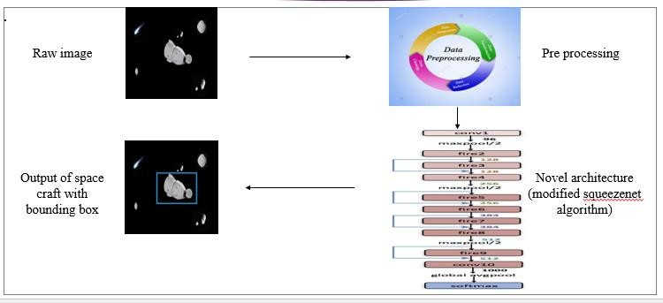

**Fig -1**: System architecture

## Dataset collection

A data set is a collection of data. Deep Learning has emerged as the preferred approach for addressing a wide range of complex real-world issues. It is without a doubt the most effective approach for computer vision tasks.

A deep network can segment and classify the "key points" of any individual in an image with enough training. These deep learning machines, which have been performing admirably, need a lot of fuel, and that fuel is data. The more labelled data available, the better our model performs. Google has also experimented with the concept of more data contributing to better results on a wide scale, with a dataset of 300 million images! When deploying a Deep Learning model in a real-world application, data must be constantly fed to continue improving its performance. And, in the deep

learning era, data is very well arguably the most valuable resource

## Preprocessing data

In this work the preprocessing data module is used to resize the images. In deep Learning module the quality of the training data determines the quality of your model. In most instances, the data you will find in practice will not be clean. It means the data will contain non-uniform data formats, missing values, outliers, and features with very different ranges. The data would not suitable to be used as training data for your model. For those reason, the data must be preprocessed in various ways.

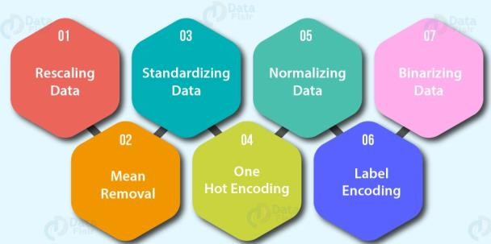

**Fig -2**: Preprocessing

## Data augmentation

The most well-known method of data augmentation is image data augmentation, which entails transforming images in the training dataset into transformed versions that belong to the same class as the original image. Shifts, turns, zooms, and other operations from the field of image processing are included in transforms. The aim is to add new, plausible examples to the training dataset. This refers to variants of the training set images that the model is likely to see. Modern deep learning algorithms, such as the convolutional neural network (CNN), can learn features that are independent of where they appear in the picture. However, augmentation can help with this transform invariant approach to learning by assisting the model in learning features that are also transform invariant, such as left-to-right to top-to-bottom ordering, light levels in images, and so on. Usually, image data augmentation is only used on the training dataset, not the validation or evaluation datasets.

## Training with novel architecture

In this work, we will be developing a novel architecture by effectively modifying the squeezenet architecture.

The main ideas of the novel architecture are:

1. Using 1x1(point-wise) filters to replace 3x3 filters, as the former only 1/9 of computation.
2. Using 1x1 filters as a bottleneck layer to reduce depth to reduce computation of the following 3x3 filters.
3. Downsample late to keep a big feature map.

The building brick of Novel architecture is called fire module, which contains two layers: a squeeze layer and an expand layer. A Novel architecture stackes a bunch of fire modules and a few pooling layers. The function map size is kept the same by the squeeze and expand layers, but the former reduces the depth while the latter increases it. In neural architectures, squeezing (bottleneck layer) and expansion behaviour is normal. To get a high level abstract, another popular trend is to increase depth while reducing feature mapsize.

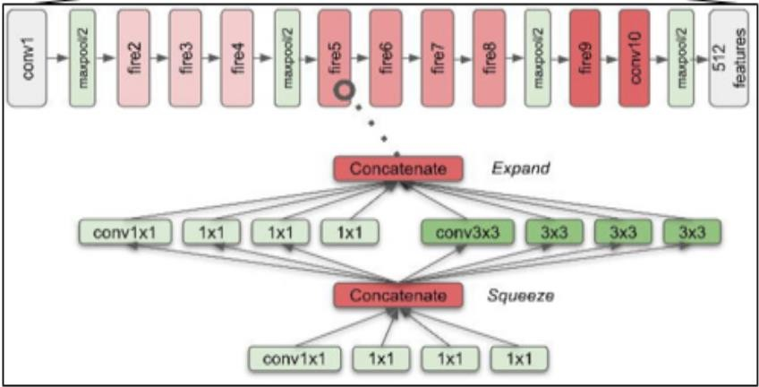

**Fig -3**: SqueezeNet

The squeeze module only has 1x1 filters, as seen in the diagram above, which means it acts like a fully-connected layer on feature points in the same position. In other words, it doesn’t have the ability of spatial abstract. One of its advantages, as the name implies, is that it reduces the depth of the function map. The following 3x3 filters in the expand layer would have less computation to do as the depth is reduced. It improves speed since a 3x3 filter needs 9 times the computation of a 1x1 filter. Too much squeezing, intuitively, limits information flow; too few 3x3 filters, on the other hand, limits space resolution.

## Object detection

Object detection is the method of accurately locating all potential instances of real-world objects in photographs or videos, such as human faces, flowers, vehicles, and so on. To identify all instances of an object type, the object detection technique employs derived features and learning algorithms.

Object detection is a technique for identifying, detecting, and localising several visual instances of objects in an image or video. Rather than just simple object classification, it offers a much clearer interpretation of the object as a whole.

This approach can be used to count the number of instances of unique objects and mark them as well as count the number of instances of unique objects. This process' efficiency has also improved over time.

To begin with, testing of the trained model, we can split our study into modules of implementation that is done. Dataset collection involves the process of collecting different space craft images for training. Various datasets were collected and one example among the collected dataset can be found below

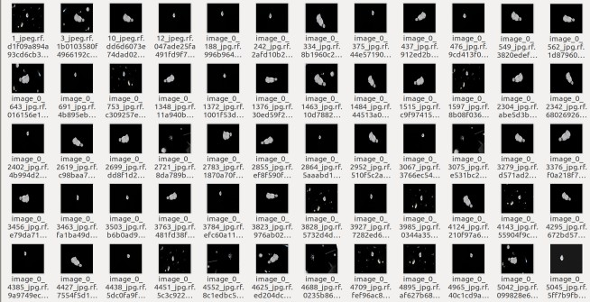

**Fig -4**: Dataset collection

The next step is data pre-processing, in this phase the spacecraft images collected are set to standard resolution format. The below screenshot shows the image before preprocessing:

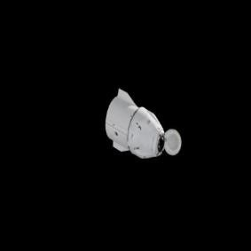

**Fig -5**: Before pre-processing

The below screenshot shows the image after preprocessing:

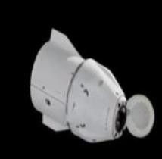

**Fig -6**: After pre-processing

The next step is data augmentation which duplicates the collected data into many images so that the prediction percentage can be increased. A sample augmentation of an image can be seen in the below figure.The below screenshot shows the image before data augmentation:

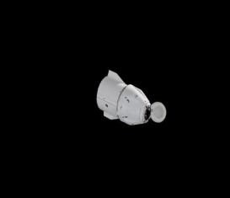

**Fig -7**: Image before data augmentation

The below screenshot shows the image after augmentation:

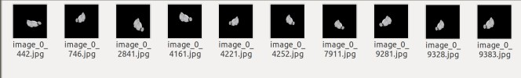

**Fig -8**: Image after data augmentation

The next step is labelling of data where the spacecraft images collected are labelled according to their nature and the images are annotated and saved in xml format. The below screenshot shows the labelling of the dataset.

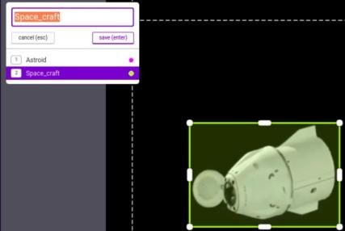

**Fig -9**: Labelling of dataset

The below image shows the training process of the work using the available deep learning architectures:

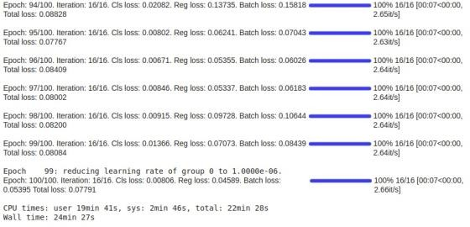**Fig -10**: Training process

In the training process, we can see the loss has got reduced in each step. The below image shows the reduction of losses.

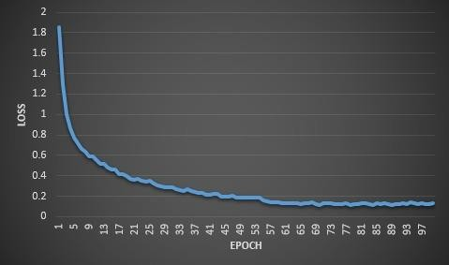

**Chart -1**: Reduction of losses

The below image shows the space craft detection of the work after training:

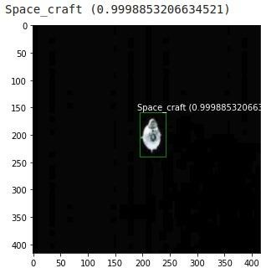

**Fig -11**: Space craft detection

The below image shows the multiple space objects detection of the work after training:

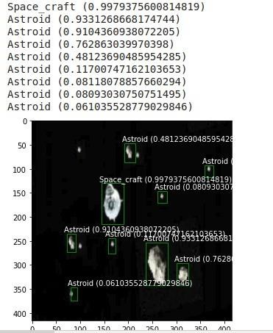

**Fig -12**: Multiple space objects detection

Thus, from the above results and discussions it is clear that the work to effectively detect and identify space objects has been effectively implemented.

## 3. CONCLUSION

This work is successfully implemented for effectively identifying the spacecrafts using the available deep learning approach. This work is very helpful in providing a cheap yet effective solution to detecting space crafts and space objects.

## REFERENCES

1. Lei Tao , Student Member, IEEE, Xue Jiang , Senior Member, IEEE, Xingzhao Liu , Member, IEEE, Zhou Li, and Zhixin Zhou,” Multiscale Supervised Kernel Dictionary Learning for SAR Target Recognition”,2020
2. Joon-Ho Lee, Hyun-Jin Moon, and So-Hee Jeong,” Numerically Efficient Determination of the Optimal Threshold in Natural Frequency-Based Radar Target Recognition”,2019
3. Jifang Pei , Student Member, IEEE, Yulin Huang, Member, IEEE, Weibo Huo, Yin Zhang , Member, IEEE, Jianyu Yang, Member, IEEE, and Tat-Soon Yeo, Fellow, IEEE,” SAR Automatic Target Recognition Based on Multiview Deep Learning Framework”,2017
4. Chunlei Huo, Member IEEE, Zhixin Zhou, Kun Ding, Chunhong Pan,” Online Target Recognition for Time- sensitive Space Information Networks”,2016
5. Xueru Bai , Member, IEEE, Xuening Zhou, Feng Zhang, Li Wang, Ruihang Xue , and Feng Zhou , Member, IEEE,” Robust Pol-ISAR Target Recognition Based on ST-MC-

DCNN”,2018

1. Tan Wu, Xi Yang, Bin Song, Nannan Wang, Xinbo Gao, Liyang Kuang, Xiaoting Nan, Yuwen Chen, Dong Yang,” T- SCNN: A Two-Stage Convolutional Neural Network for Space Target Recognition”,2017
2. Lin Chen , Student Member, IEEE, Xue Jiang , Senior Member, IEEE, Zhou Li, Xingzhao Liu , Member, IEEE, and Zhixin Zhou,” Feature-Enhanced Speckle Reduction via Low-Rank and Space-Angle Continuity for Circular SAR Target Recognition”,2015
3. Jiemin Hu, Wei Wang, Qinglin Zhai, Jianping Ou, Ronghui Zhan, and Jun Zhang,” Global Scattering Center Extraction for Radar Targets using a Modified RANSAC Method”,201
4. Zhiqiang He , Huaitie Xiao, Chao Gao, Zhuangzhuang Tian, and Si-Wei Chen , Senior Member, IEEE,” Fusion of Sparse Model Based on Randomly Erased Image for SAR Occluded Target Recognition”,2016
5. Nasser M. Nasrabadi, Fellow, IEEE,” DeepTarget: An Automatic Target Recognition using Deep Convolutional Neural Networks”,2017
6. Haibin Duan, Senior Member, IEEE, and Lu Gan,” Elitist Chemical Reaction Optimization for Contour-Based Target Recognition in Aerial Images”,2018
7. Ming Liu , Shichao Chen , Jie Wu , Fugang Lu, Xili Wang, and Mengdao Xing, Member, IEEE,” SAR Target Configuration Recognition via Two-Stage Sparse Structure Representation”,2015
8. Lan Du, Senior Member, IEEE, Jian Chen, Jing Hu, Yang Li, Hua He,” Statistical Modeling with Label Constraint for Radar Target Recognition”,2016
9. Baiyuan Ding and Gongjian Wen,” Target Reconstruction Based on 3-D Scattering Center Model for Robust SAR ATR”,2019
10. Yao-tung tsou1 , yung-li hu2 , yennun huang3 , (fellow, ieee), and sy-yen kuo2 , (Fellow, IEEE), ” SFTopk: Secure Functional Top-k Query via Untrusted Data Storage”,2017